Darius Quick
8/07/25
Project One Images
Questions API Created 1
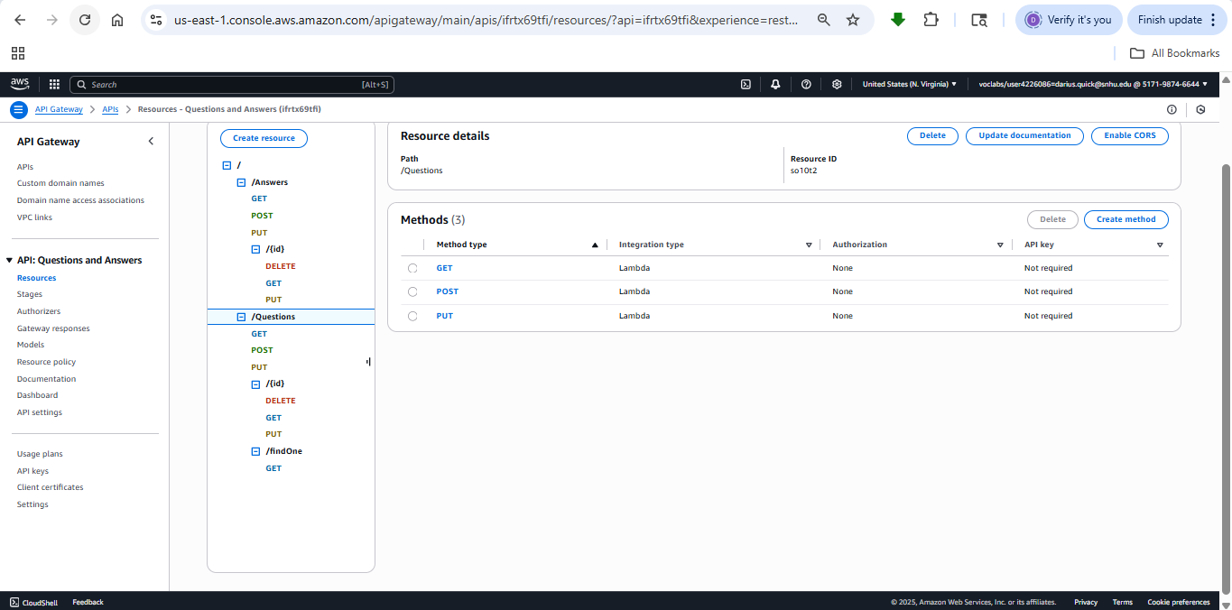
Questions API Created 2
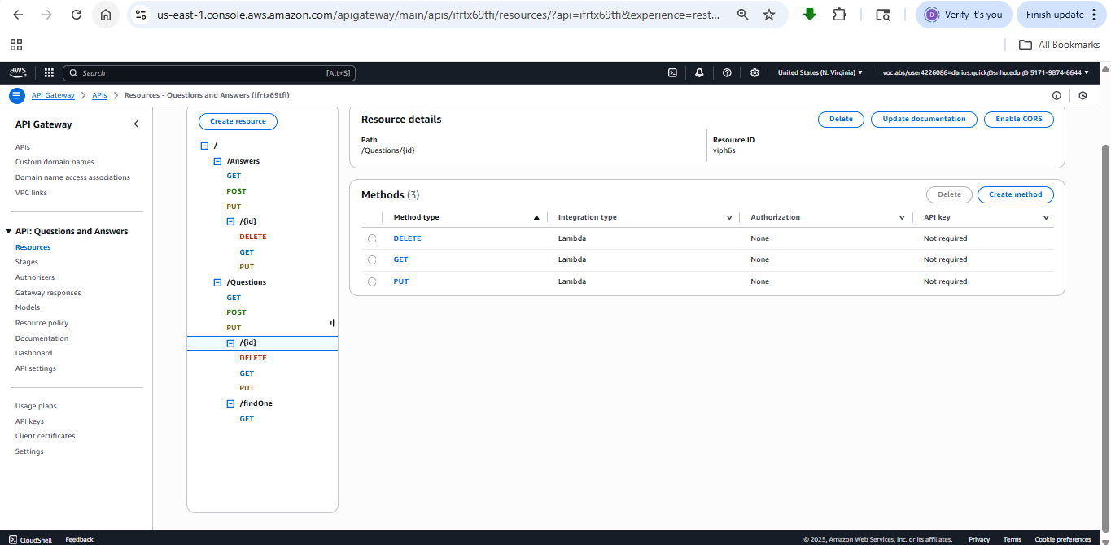
Questions API Created 3
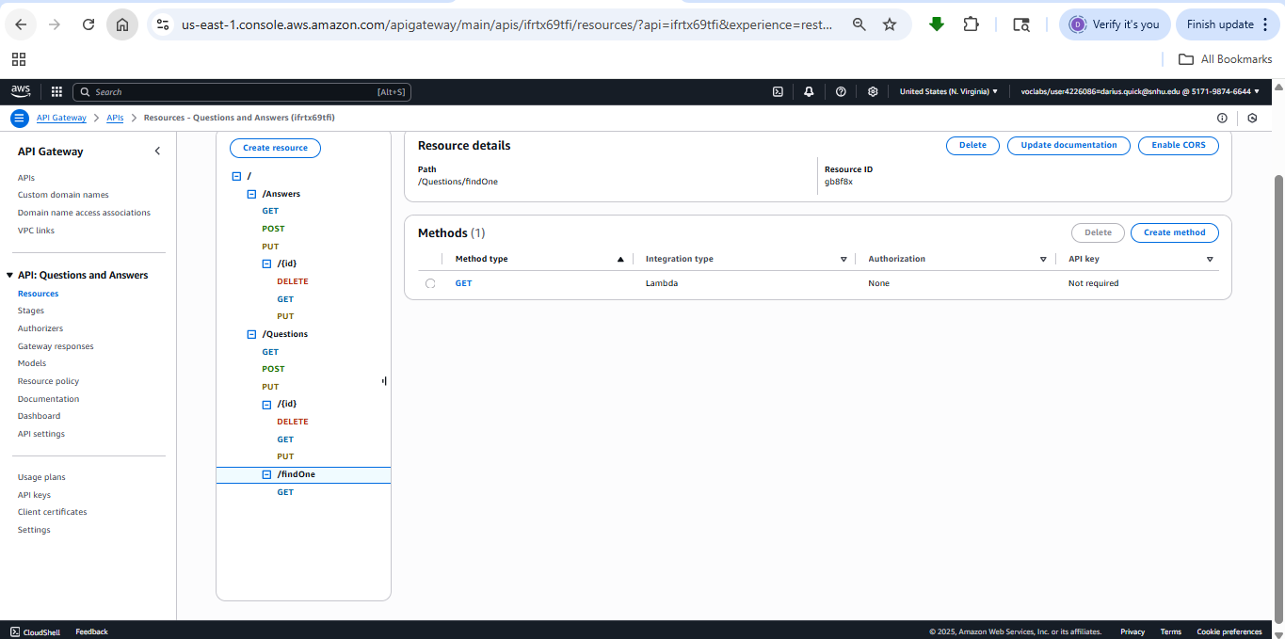
Added Questions Headers 1
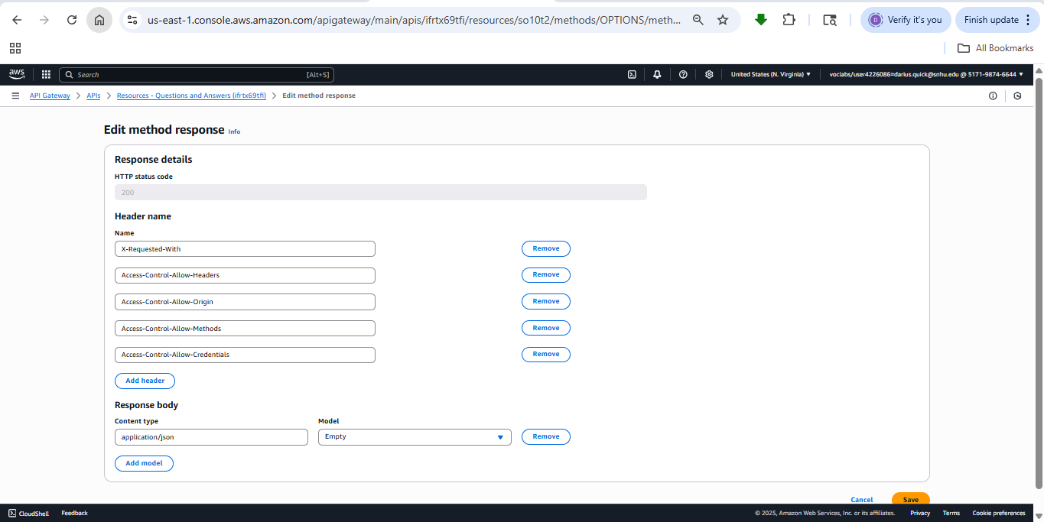
Added Questions Headers 2
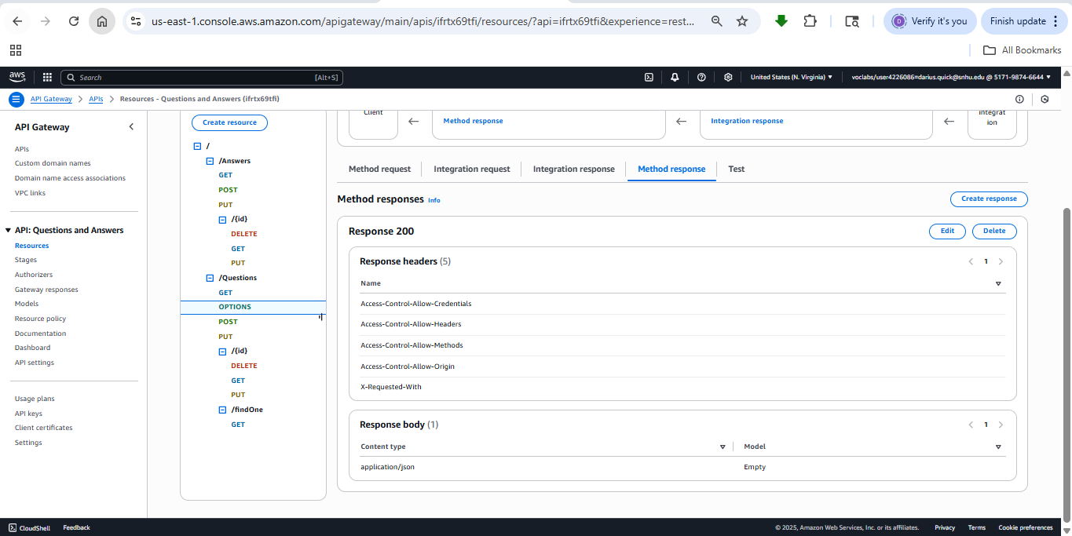
Set Question Header Mappings 1
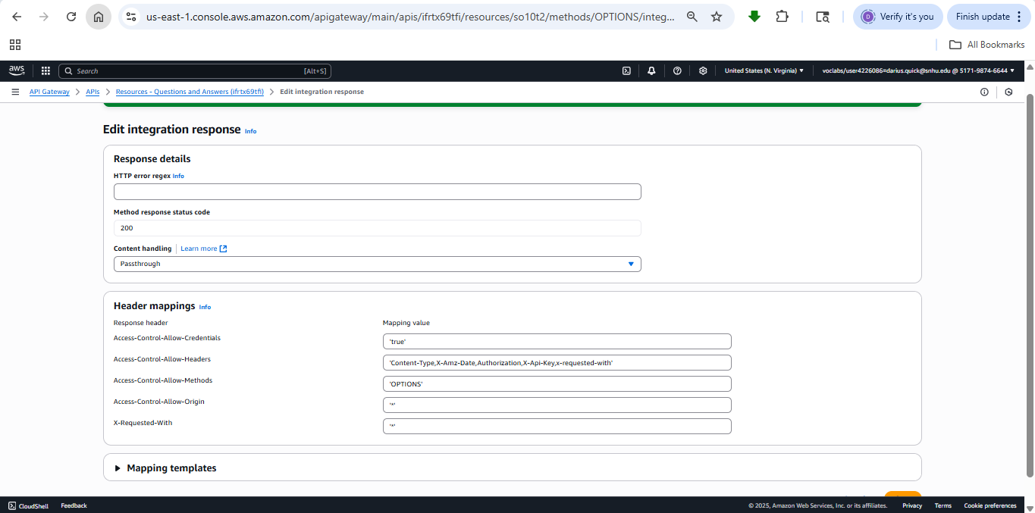
Set Question Header Mappings 2
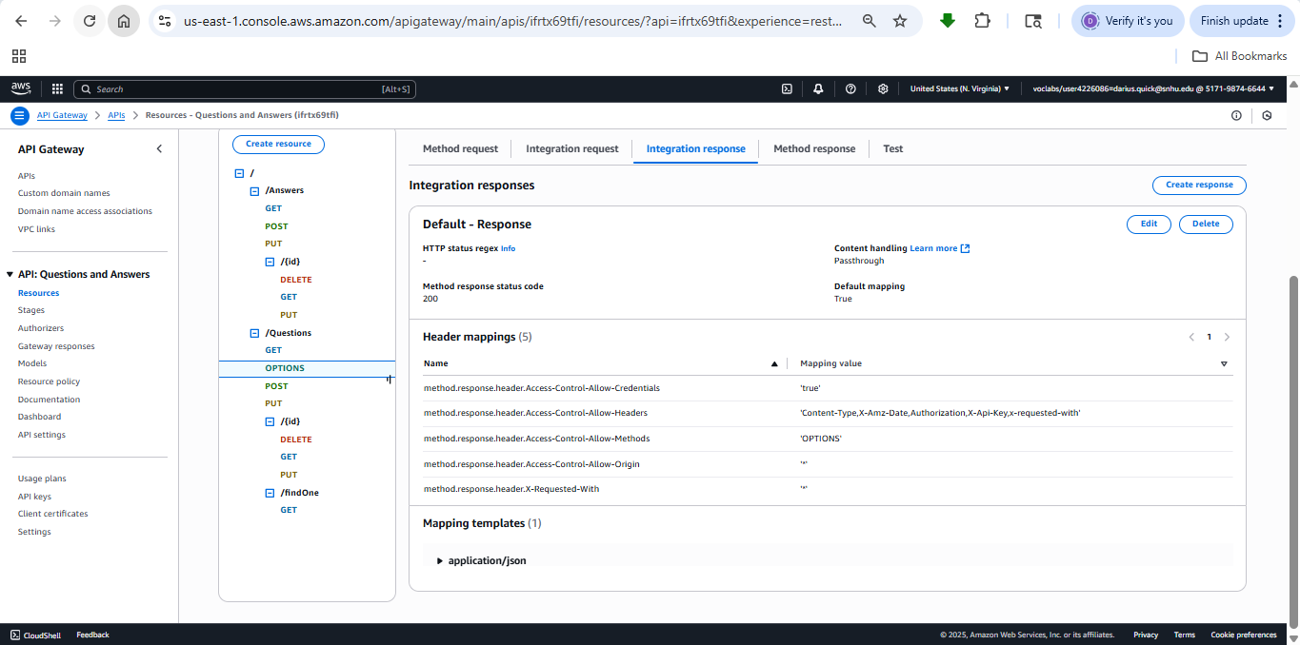
Answers API Created 1
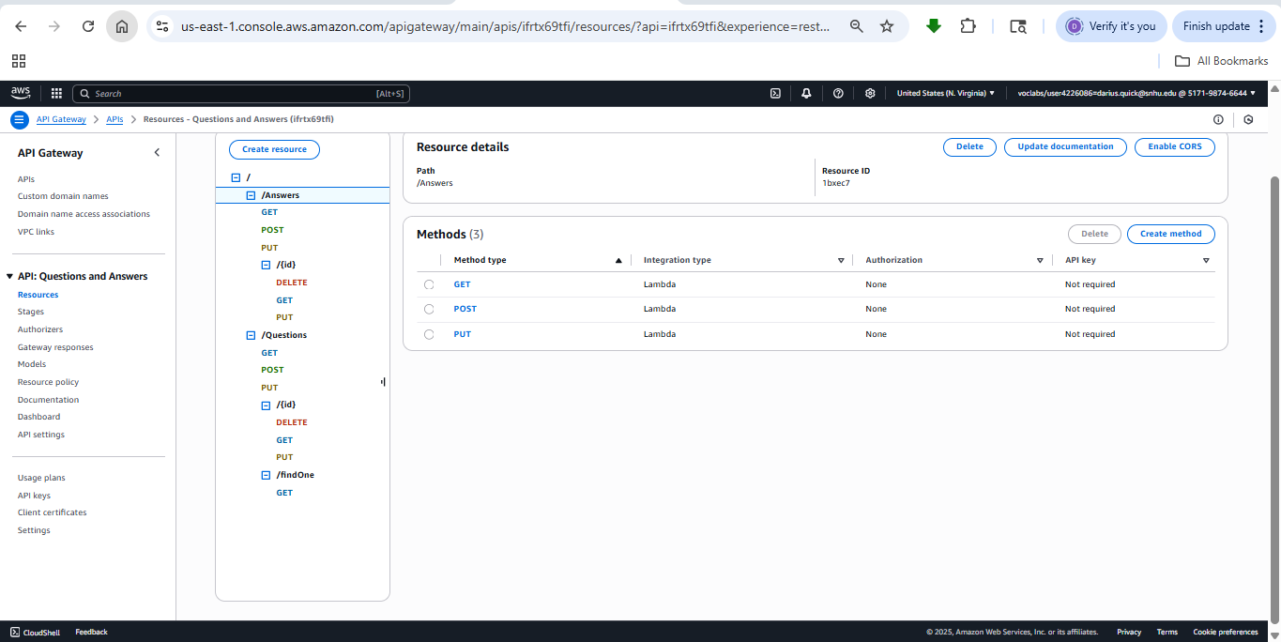

Answers API Created 2
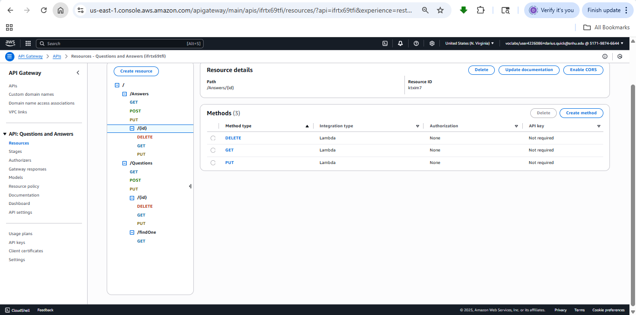
Deployed API
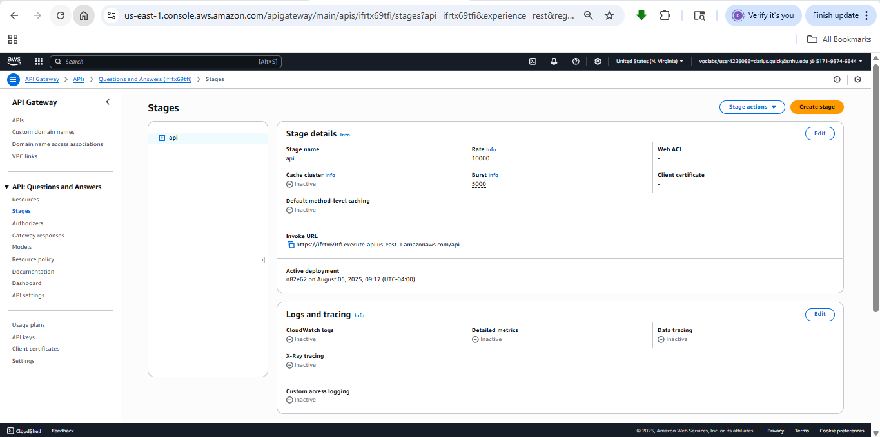

Successfully loaded the Questions API Backend Website Page 1
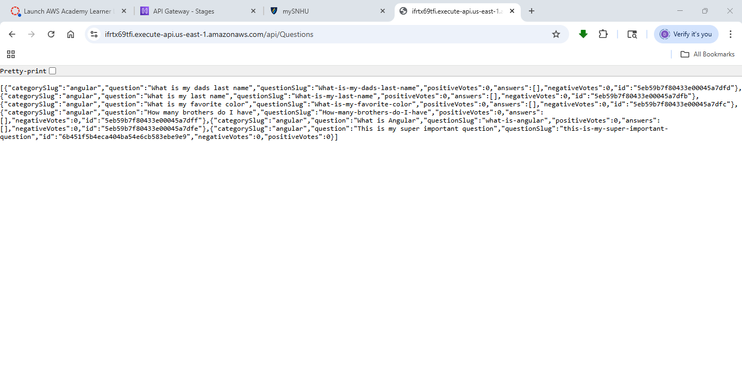
Successfully loaded the Questions API Backend Website Page 2
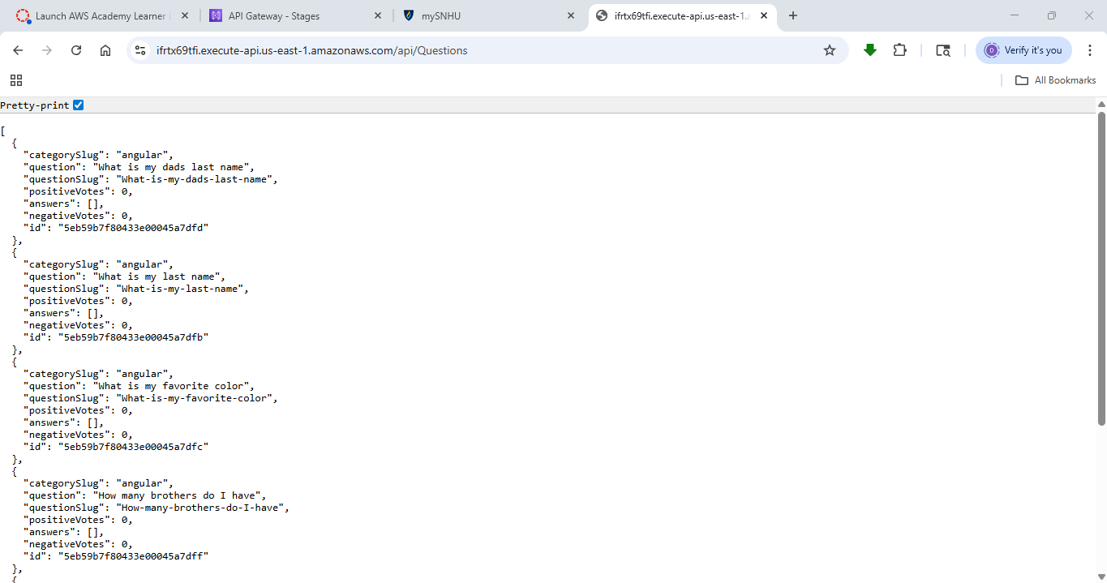
Successfully loaded the Answers API Backend Website Page 1
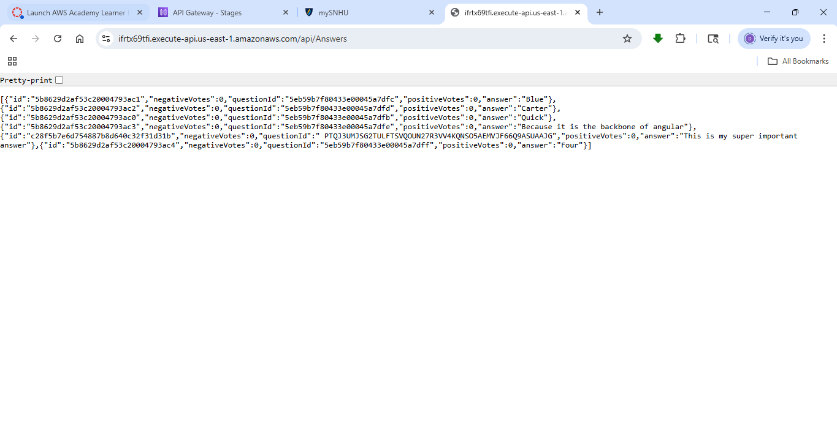
Successfully loaded the Answers API Backend Website Page 2
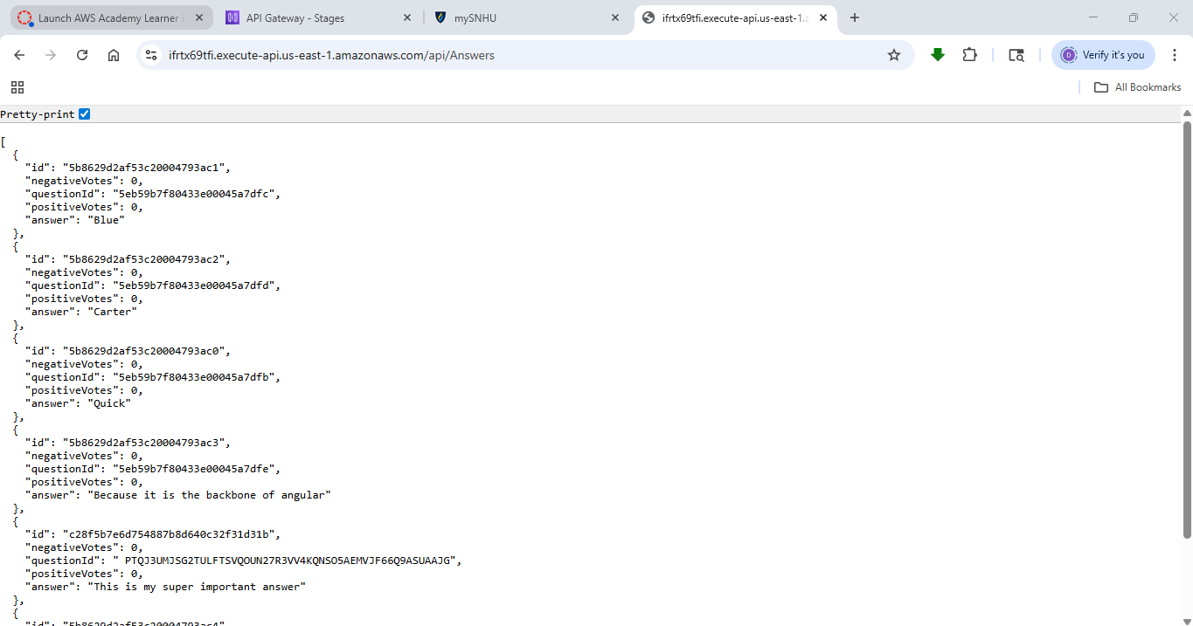

Created S3 Bucket for Static Website
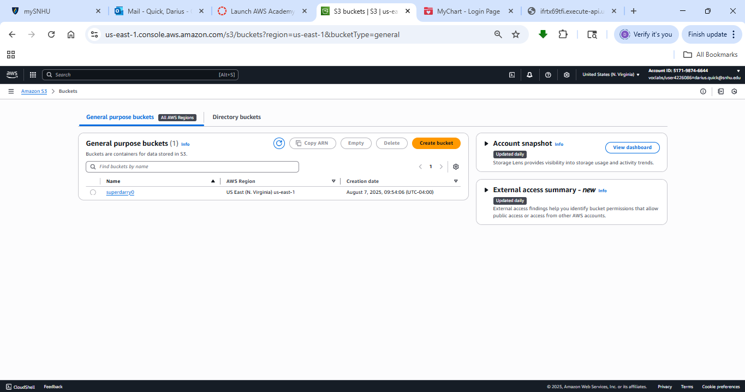
Uploaded Website Angular Contents into the S3 Bucket
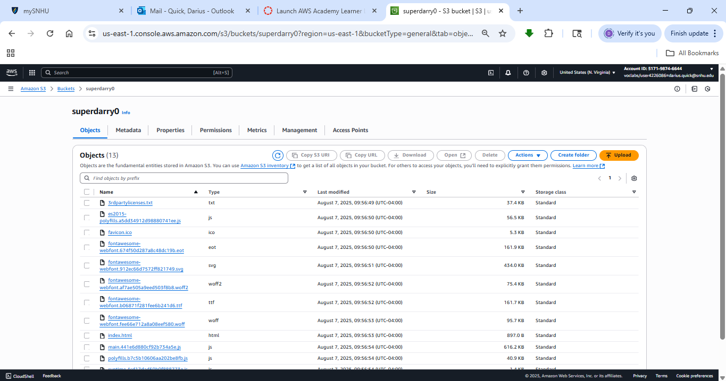
Disabled Block Public Access for S3 Bucket
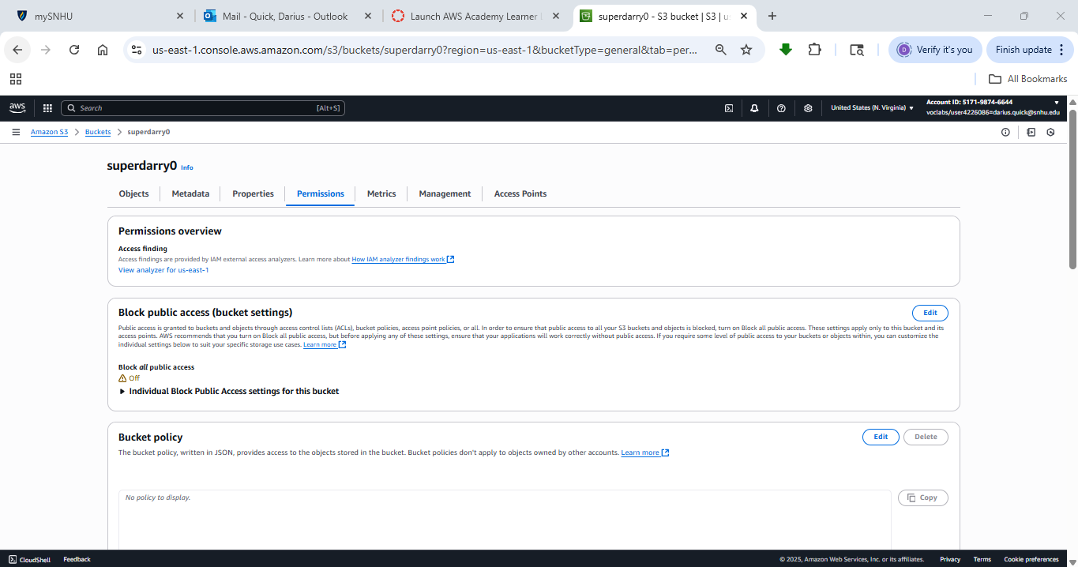
Added Bucket Policy
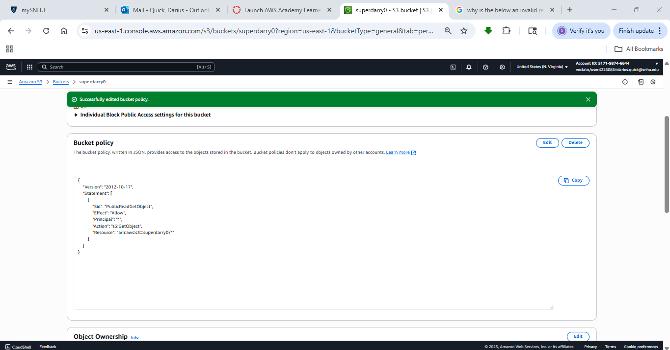
Successfully loaded S3 Static Website Front End
